**VOCATIONS NEWSLETTER**

THE FUTURE OF VOCATION

TUESDAY, 12TH NOVEMBER 2024

We often read about a decline in the number of people putting themselves forward for ordained and lay ministry, but what is God saying to the church in the midst of these anxieties? You are warmly invited to join us for a day of reflection on the future shape of Vocation in the Church of England on Tuesday, 12th November at Cuddesdon.

The Programme will include input from Canon Dr Joanna Collicutt, Theologian and Psychologist of religion, one of our Associate Tutors and Fellow of Harris Manchester College. There will also be a panel discussion with external representatives from bodies involved in vocations, as well as Cuddesdon students and staff. There will also be time to meet with students, to have a one-to-one conversation with our Admissions Tutor, or to tour the site and our facilities. The day will conclude with an optional Eucharist in the award-winning Edward King Chapel. Overnight accommodation for the night before or night after the day is included.

The day is, of course, open to everyone involved in your vocations team. Further details will follow in the next few months but if you would like to register your interest in coming, please [admissions@rcc.ac.uk](mailto:admissions@rcc.ac.uk).

Part of the reading of the Passion on Good Friday

RETREATANTS JOIN US FOR THE TRIDUUM

The College observed Triduum this year from the evening of Maundy Thursday ending with a "champagne" breakfast on Easter Day, as a time to (re-)unite with Christ in his passion death and resurrection. The whole community of students, families and staff were involved with a range of worship, vigil, children's garden-making and fireside stories, and Easter Day celebration.

It was a privilege to share the Triduum with ten retreatants who are currently exploring their vocation. They were able to experience our community and a taste of life in a theological college. Unfortunately we were not able to host everybody who expressed an interest, but there will be another similar opportunity for those recommended by their DDOs to join us for a Part-Time Pathway residential weekend focused on worship and preaching in the Hilary Term 2025. If you have any candidates now or in the next few months that you think may benefit from the experience, please contact [admissions@rcc.ac.uk](mailto:admissions@rcc.ac.uk).

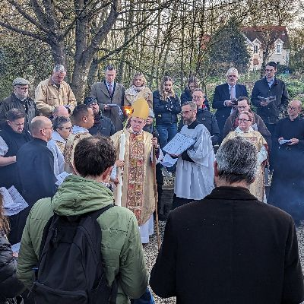

The lighting of the Paschal Candle from the Vigil fire at dawn on Easter morning

Our Open Day dates for full-time, context-based and part-time training at Cuddesdon are on:

Saturday 20th April 2024

Saturday, 9th November 2024

Saturday. 25th January 2025

Saturday, 17th May 2025

All admissions enquiries can be made to: admissions@rcc.ac.uk or 01865 874404.

enquiries@rcc.ac.uk 01865 874404 www.rcc.ac.uk