Printout of e-newsletter



VOCATIONS NEWSLETTER
Michaelmas Term 2024

The new academic year is well underway and students have settled in well to the busyness of community, teaching and patterns of college life. We have a smaller cohort of full-time residential students this year, as is the national trend, but large and healthy cohorts of full-time non-residential (context based) and part-time students which make for exceedingly full and vibrant mid-week evenings and residential weekends.
We are excited to have made an excellent appointment to spearhead our Incumbent Development Programme, starting in January 2025, and also to lead our new pathway (from September 2025) for Children’s Young People’s and Families’ workers. As well as developing these new strands of work, our new colleague will also be helping us develop and orientate our ordinand pathways curricula with the needs of ministry with young people to the fore, thus driving forward our intention to form ministers who are confident and enthusiastic to minister in a church that is ‘growing younger’.
We are greatly looking forward to welcoming a group of DDOs, ADDOs and vocations advisers to our Future of Vocations day conference on Tuesday, 12 November. If you are not already signed up and would be interested to listen to Canon Dr Joanna Collicutt talk on Psychology and Vocation, and hear a panel of experts involved in the discernment process give their perspectives on vocations, then it is not too late to book your place - the Programme is available here.
We are pleased to have added some videos to our website of staff and students saying what they value about Cuddedon. Please click on the link below to watch our Welcome to Cuddesdon overview on the homepage, and you can then click through to pathway pages to hear students talk about their own experiences:
Welcome to Cuddesdon Video

Invitation to experience a training weekend at a theological college
Following the success of last year’s invitation to DDOs to nominate people in the discernment process to attend our 2024 Triduum, we would like to make a similar opportunity available this academic year.
We are offering the chance for prospective ordinands to attend a Cross-Pathways Residential Weekend at Cuddesdon and experience first-hand what training at theological college might be like. The weekend will take place on 25 – 27 April 2025, and will include a welcome session and tour of Oxford specifically for these guests, alongside the opportunity for them to join in with weekend teaching, which will be on the topic of Christian Worship and Preaching.
If you think that this would be a good opportunity for any of your candidates, do please encourage them to reach out to us at admissions@rcc.ac.uk and register their interest. As you can imagine, we only have a limited number of places available for this weekend, so you may like to check with colleagues in your diocese about which candidates you wish to put forward.

BOOK LAUNCH: So Longeth My Soul
by Canon Dr Joanna Collicutt
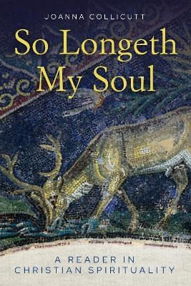
Canon Dr Joanna Collicutt, our Associate Lecturer in Psychology and Spirituality, will be holding the launch of her latest book at our Future of Vocations day. So Longeth My Soul - A Reader in Christian Spirituality offers a collection of readings from the classic texts of Christian spirituality but also gives the reader a way into these texts that enables them to be received as living and relevant for both personal spirituality and ministry.
All are welcome to the Book Launch at 3.45pm on Tuesday, 12 November where the book will be available to buy or it can be purchased directly from SCM Press here.

Our Open Day dates for full-time, context-based and part-time training at Cuddesdon are on:
- Saturday, 25th January 2025
- Saturday, 17th May 2025
All admissions enquiries: admissions@rcc.ac.uk or 01865 874404.

www.rcc.ac.uk

